

Phase 2
June 2026
XStep Design Specification
SMPL: Total Medium Added

Table of Contents
Right-click and choose Update Field to build the table of contents.

Purpose
This document outlines the functional and technical design, along with the configuration specifications for the XStep “SMPL: Total Medium Added”.

Overview
The SMPL: Total Medium Added XStep allows operators to record and total the amount of cryoprotectant medium used in each centrifuge tube. The process step is configured to validate that no more than 3ml of cryoprotectant is added to each tube.

Functional Design
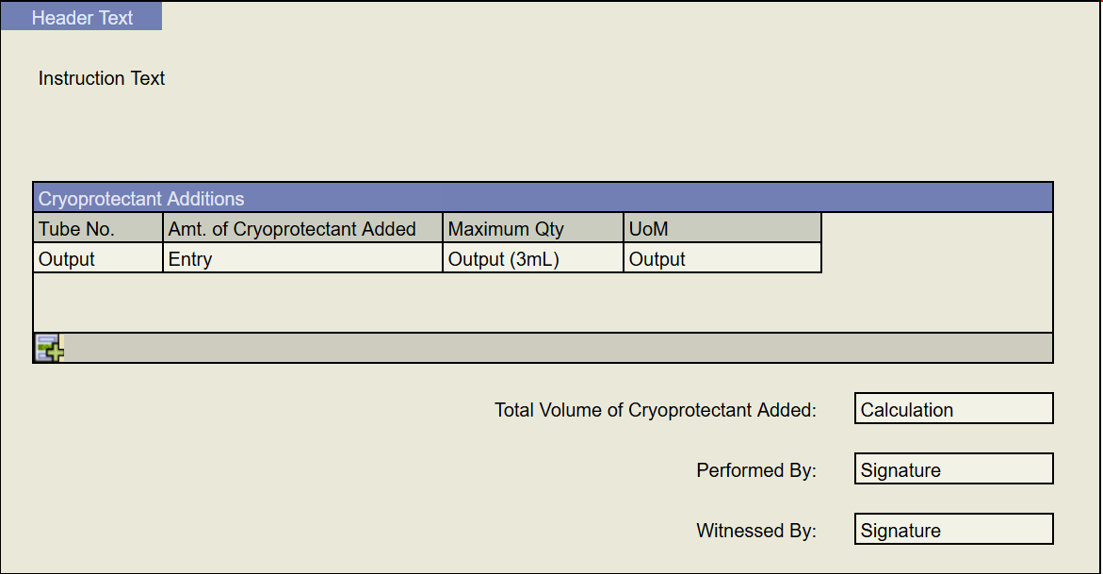

The instruction Text can be set in MBR to the following:
“
Gently loosen the pellet by pipetting up and down.
<b>NOTE: If needed, add no more than 3mL of cryoprotectant medium (8008618) per centrifuge to loosen the pellet.</b>
Record the total amount of Cryoprotectant Medium <b>(8008618)</b> added to each centrifuge tube to loosen pellet, if applicable.
“

Users may enter a quantity of cryoprotectant medium into each table row. Values entered into this “amt. of cryoprotectant added” field will be validated by ZSMPL_FM_MIN_MAX such that they are a positive number no greater than 3mL. Otherwise, a validation error will be raised.
Below, an output calculation will display the total sum of values entered into the cryoprotectant medium table.
The performed by and witnessed by signatures will validate that the user is signed into the PI Sheet before allowing for the signature to continue. They will both use their respective signature strategies, and the witnessed by signature must be completed by a different user than the performed by signature.

Reasons for developing
The SMPL: Total Medium Added XStep was developed to record any and all additions of cryoprotectant medium to the centrifuge tubes.

Authorization
N/A

Assumptions/ Dependencies
 | Assumption
1 | Master Data has been set up correctly
2 | The function module is available, runs whenever an amount of cryoprotectant is added, and raises an error if validation is incorrect.

Validation Checks
Error Handling
Error | Action
Entered Medium is outside of tolerance (+/- 3mL) | Validation Triggers stating the value is outside of the tolerance

XStep Layout Design
Screenshot of Final Design

Function Module(s)
Function: ZSMPL_FM_CUSTOM_INDEX
Import Parameters:
Parameter Name | Associated Type | Short Text
IM_PRE_TEXT | CHAR10 | Prefix text (optional)

Changing Parameters:
Parameter Name | Associated Type | Short Text
CH_INDEX1 | /SMPL/STR_TT_RSNUM | Index column – table 1
CH_INDEX2 | /SMPL/STR_TT_RSNUM | Index column – table 2 (optional)
CH_INDEX3 | /SMPL/STR_TT_RSNUM | Index column – table 3 (optional)

Function: ZSMPL_FM_VALIDATE_QUANTITY
Import Parameters:
Parameter Name | Associated Type | Short Text
IM_QTY_NUM | ERFMG | Quantity (numeric, optional)
IM_QTY_CHAR | CHAR30 | Quantity (character, optional)
IM_FLAG | BOOLEAN | Exact-match flag
IM_TARGET | ERFMG | Target value (optional)
IM_MIN | ERFMG | Minimum tolerance (optional)
IM_MAX | ERFMG | Maximum tolerance (optional)

Exceptions:
Exception | Short Text
VALUE_OUTSIDE_TOLERANCE | Value outside tolerance
TARGET_VAL_NOT_FOUND | Target value not provided

Function: /SMPL/PPPI_FM_GET_DATE_TIME
Import Parameters:
Parameter Name | Associated Type | Short Text
IV_COMPLETE | CHAR1 | Character 1

Export Parameters:
Parameter Name | Associated Type | Short Text
EV_DATE | DATS | Date
EV_TIME | TIMS | Time
EV_DATE_DEFAULT | DATS | Date
EV_TIME_DEFAULT | TIMS | Time

Exceptions:
Exception | Short Text
PERIOD_COMPLETED | Raised/handled when the period has already been completed

Function: /SMPL/PPPI_FM_INITIAL_ACTIVE
Import Parameters:
Parameter Name | Associated Type | Short Text
IV_ACTIVE | CHAR1 | N/A

Export Parameters:
Parameter Name | Associated Type | Short Text
EV_ACTIVE | CHAR1 | N/A

Function: /SMPL/MBR_DEP_CHECK_ACTIVE
Import Parameters:
Parameter Name | Associated Type | Short Text
IM_CONTROL_RECIPE | POC_DOCID | N/A
IM_PHASE | VORNR
IM_AUFNR | AUFNR
IM_STEP_UUID | /SMPL/MBR_SOG_UUID
IM_PLANT | WERKS_D

Export Parameters:
Parameter Name | Associated Type | Short Text
EV_ACTIVE | CHAR1 | N/A

Exceptions:
Exception | Short Text
CONTROL_RECIPE_INITIAL

Pseudocode
Function: ZSMPL_FM_CUSTOM_INDEX
1. Purpose
Numbers each row of a table sequentially (1, 2, 3 …) and optionally mirrors that numbering into up to two additional index columns so parallel tables stay in sync. An optional text prefix can be prepended to each generated row number.
2. Input Parameters
• IM_PRE_TEXT – optional text placed in front of each generated row number.
• CH_INDEX1 – primary index column to number (changing).
• CH_INDEX2 / CH_INDEX3 – optional additional index columns kept in step with CH_INDEX1.
3. Processing Logic
a. If CH_INDEX2 is already populated and equals CH_INDEX1, exit immediately to avoid unnecessary re-processing.
b. Loop over CH_INDEX1; for each row set the value to the current row number (sy-tabix), prefixed with IM_PRE_TEXT when one is supplied.
c. Copy the completed CH_INDEX1 into CH_INDEX2 and CH_INDEX3 so every index column matches.
Additional Notes
Error Handling:
• No exceptions are defined.
Dependencies:
• Table type /SMPL/STR_TT_RSNUM; no database reads or external FM calls.
Assumptions:
• All supplied index columns have the same number of rows so they remain aligned.

Function: ZSMPL_FM_VALIDATE_QUANTITY
1. Purpose
Validates an entered quantity either against an exact target value or within a configured minimum/maximum range, depending on a flag.
2. Input Parameters
• IM_QTY_NUM / IM_QTY_CHAR – the entered quantity as a number or as text.
• IM_FLAG – when set, validate against an exact target; otherwise validate against a range.
• IM_TARGET – exact target value (exact-match mode).
• IM_MIN / IM_MAX – minimum and maximum tolerance (range mode).
3. Processing Logic
a. Resolve the actual quantity: prefer IM_QTY_NUM, otherwise convert IM_QTY_CHAR to numeric – raise VALUE_OUTSIDE_TOLERANCE if it is not a number.
b. Exact-value mode (IM_FLAG set): raise TARGET_VAL_NOT_FOUND when no target is supplied, then raise VALUE_OUTSIDE_TOLERANCE when the quantity does not equal IM_TARGET.
c. Range mode (IM_FLAG not set): raise VALUE_OUTSIDE_TOLERANCE when the quantity is below IM_MIN or above IM_MAX.
Additional Notes
Error Handling:
• VALUE_OUTSIDE_TOLERANCE – the quantity is non-numeric, not equal to the target, or outside the range.
• TARGET_VAL_NOT_FOUND – exact-match mode was requested but no target value was supplied.
Dependencies:
• None – numeric comparison only.
Assumptions:
• The appropriate target or min/max tolerances are configured for the column being validated.

Function: /SMPL/PPPI_FM_GET_DATE_TIME
1. Purpose
Returns the current local date and time for use in a process instruction (XStep) entry, unless the period/XStep has already been completed, in which case it issues an information message and does nothing.
2. Input Parameters
• IV_COMPLETE – completion flag; '1' means the period has already been completed.
Export Parameters
• EV_DATE / EV_TIME – current local date and time.
• EV_DATE_DEFAULT / EV_TIME_DEFAULT – default copies of the same date and time.
3. Processing Logic
a. If IV_COMPLETE = '1', issue information message 008 ('Period has been completed, remove completion before updating') and EXIT without setting any values.
b. Otherwise set EV_DATE = sy-datlo and EV_TIME = sy-timlo (current local date/time).
c. Copy those values into EV_DATE_DEFAULT and EV_TIME_DEFAULT.
Output
• Current local date/time in both the working and default export fields.
Additional Notes
Error Handling:
• PERIOD_COMPLETED – declared exception; in practice completion is signalled via information message 008 and an early EXIT rather than RAISE.
Dependencies:
• System fields sy-datlo / sy-timlo; message class message 008; constant gc_type_i (message type 'I').
Assumptions:
• IV_COMPLETE = '1' reliably indicates a completed period that must not be re-dated.

Function: /SMPL/PPPI_FM_INITIAL_ACTIVE
1. Initialization
a. Input parameter IV_ACTIVE is optionally provided by the calling logic.
b. Constants gc_yes, gc_no, and gc_inside_range are assumed to be defined globally in the context of the function module.
2. Active Flag Evaluation
a. The function checks if the input value IV_ACTIVE falls within the expected valid range, represented by gc_inside_range.
b. Based on the result:
• If the input value is not equal to gc_inside_range, the XStep is marked as inactive by setting EV_ACTIVE = gc_no.
• If the input value is equal to gc_inside_range, the XStep is marked as active by setting EV_ACTIVE = gc_yes.
3. Output Assignment
a. The evaluated result is returned in the EV_ACTIVE export parameter for use by the calling logic (e.g., XStep configuration, PI sheet rendering).
Additional Notes
• This is a simple normalization function that abstracts how activation flags are interpreted for PPPI XSteps.
• The use of constants (gc_yes, gc_no, gc_inside_range) aligns the logic with broader application settings or standards.
• Input is optional, so defaulting behavior can be configured outside this function.

Function: /SMPL/MBR_DEP_CHECK_ACTIVE
1. Initialization
a. Input parameters provide context for determining whether an MBR step can be activated:
• IM_CONTROL_RECIPE (POC_DOCID) – Control recipe ID identifying the batch instruction.
• IM_PHASE (VORNR) (Optional) – Operation or phase within the process order.
• IM_AUFNR (AUFNR) (Optional) – Process order number associated with the step.
• IM_STEP_UUID (/SMPL/MBR_SOG_UUID) – Unique step identifier (SOG).
• IM_PLANT (WERKS_D) – Plant code for process context.
b. The function validates that IM_CONTROL_RECIPE is not initial; if it is, CONTROL_RECIPE_INITIAL is raised. Internal data is initialized and routine LOAD_INTERNAL_DATA populates the order dependency buffers.
2. Signature Data Retrieval
a. Signature records for the process order are retrieved from /SMPL/MBR_OR_SIG (AUFNR = IM_AUFNR) into internal table lt_ord_sigs for evaluation.
3. Dependency Evaluation
a. The function loops through dependencies where TARGET_UUID = IM_STEP_UUID and DEP_RULE is a Perform-Before-Start or Verify-Before-Start rule:
• For PERFORM BEFORE START, it checks whether the prerequisite step has a pending perform signature.
• For VERIFY BEFORE START, it checks whether the prerequisite step has a pending verify signature.
b. If an incomplete signature is found, the step is marked inactive (EV_ACTIVE = gc_step_inactive); if all prerequisites are complete, it is marked active (EV_ACTIVE = gc_step_active).
4. Output Assignment
a. The evaluated activation status is returned in EV_ACTIVE (active = all prerequisites complete; inactive = at least one prerequisite incomplete).
Additional Notes
• Evaluates Perform Before Start and Verify Before Start dependency rules using live signature data from /SMPL/MBR_OR_SIG.
• Error Handling: raises CONTROL_RECIPE_INITIAL if the control recipe is missing; handles empty dependency/signature data without runtime errors.
• Activation status is recalculated each time the function is called to reflect live signature data.

Configuration Specifications
N/A

Test Scenarios
Variant 1: Equipment Select
# | Scenario | Expected Result | Actual Result | Pass/ Fail
1 | Create and Release a Process Order with the pre-configured SiMPL Master Recipe and the relevant Production Version | Process Order created and Released containing SMPL: Total Medium Added | Process Order created and Released containing SMPL: Total Medium Added
2 | Open the EBR and navigate to Phase 0030 and then navigate to SMPL: Total Medium Added | The EBR for the selected Process Order and Control Recipe opens successfully without any errors and the SMPL: Total Medium Added step is visible in Phase 0030 | The EBR for the selected Process Order and Control Recipe opens successfully without any errors and the SMPL: Total Medium Added step is visible in Phase 0030
3 | Add rows to the cryoprotectant additions table | Table rows are added with the correct auto-index number (1, 2, 3..)
4 | Enter an amount of cryoprotectant medium greater than 3 | Deviation error occurs
5 | Enter amounts of cryoprotectant medium less than 3 in multiple table lines | Total medium field at the bottom shows sum of all rows with no errors

Document References
Reference No. | Document Title
Number used in superscript for reference | Full name of referenced document
1 | SiMPL Functional Guide: Universal Concepts

Revision History
Version No. | Description | Author | Date
1 | Initial Functional Design Information | Martin Van Laethem | May 04 2026
1.1 | Technical Design Information | Dev Name | Date

